Task on IAM
- Create one IAM user and assign EC2 and S3 full access roles.
- Navigated to IAM service and opened Users.
- Clicked Create User and entered username.
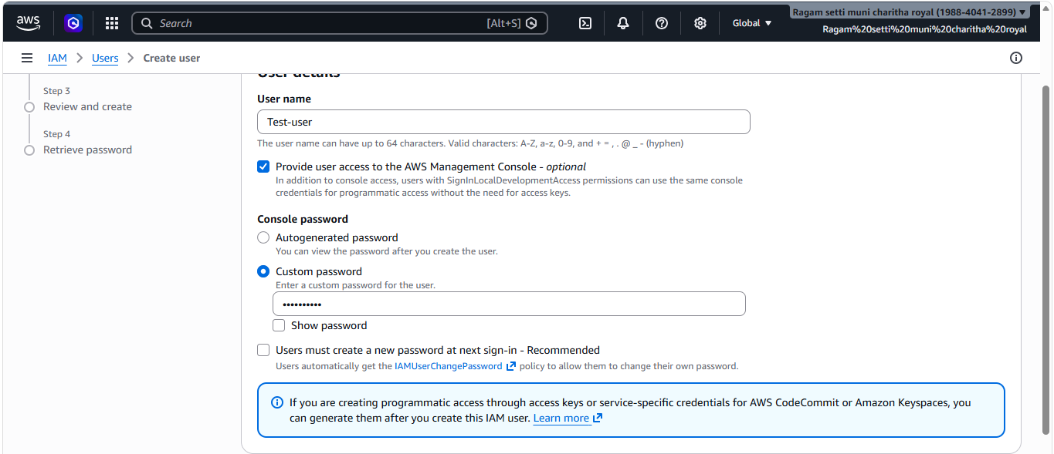
- Selected Attach policies directly.
- Added AmazonEC2FullAccess and AmazonS3FullAccess.
- Clicked Create User.
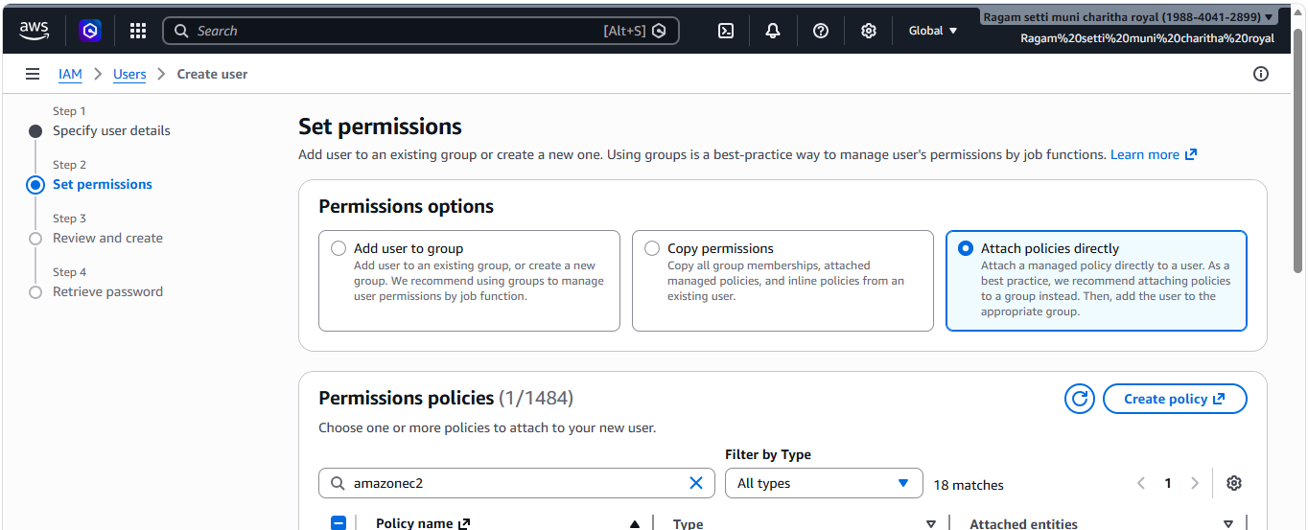
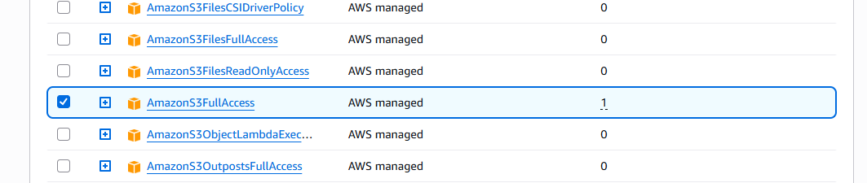
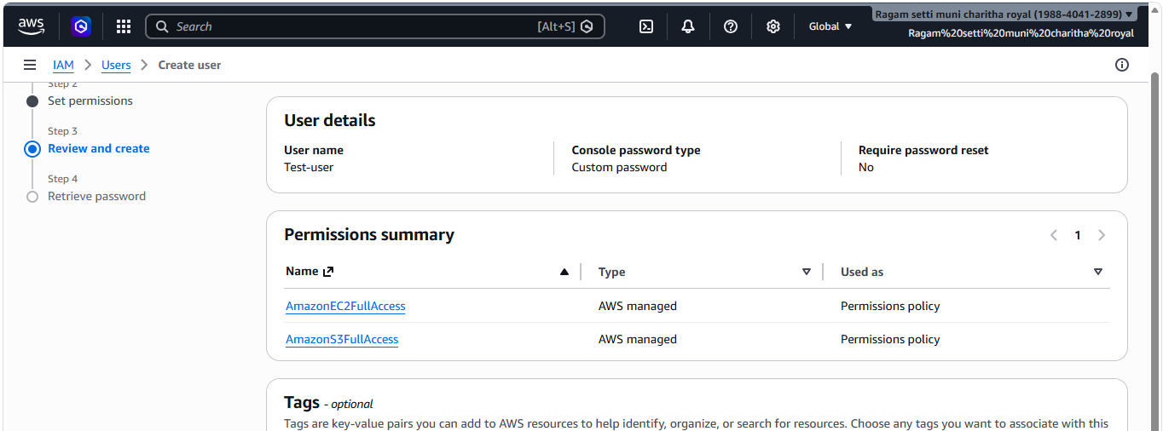
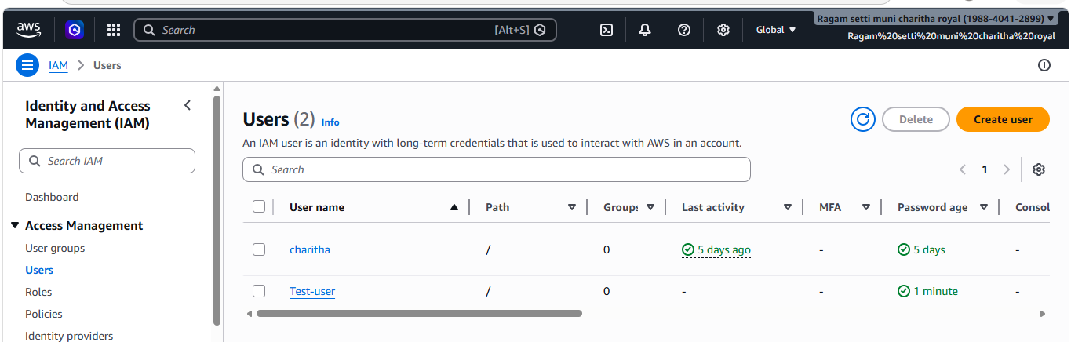
- Logged in with IAM user credentials.
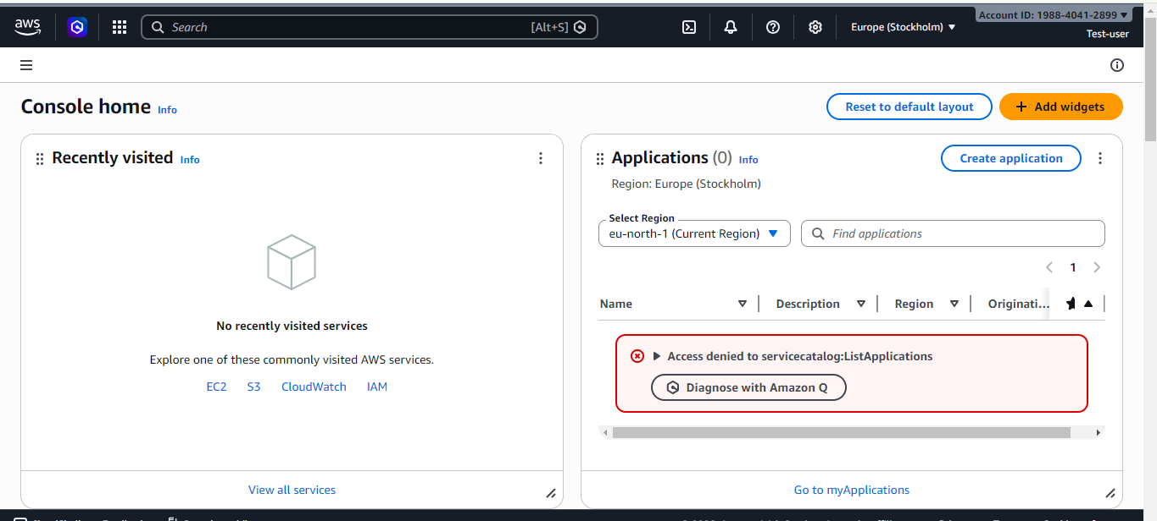
- Checked access for EC2 and S3 services.
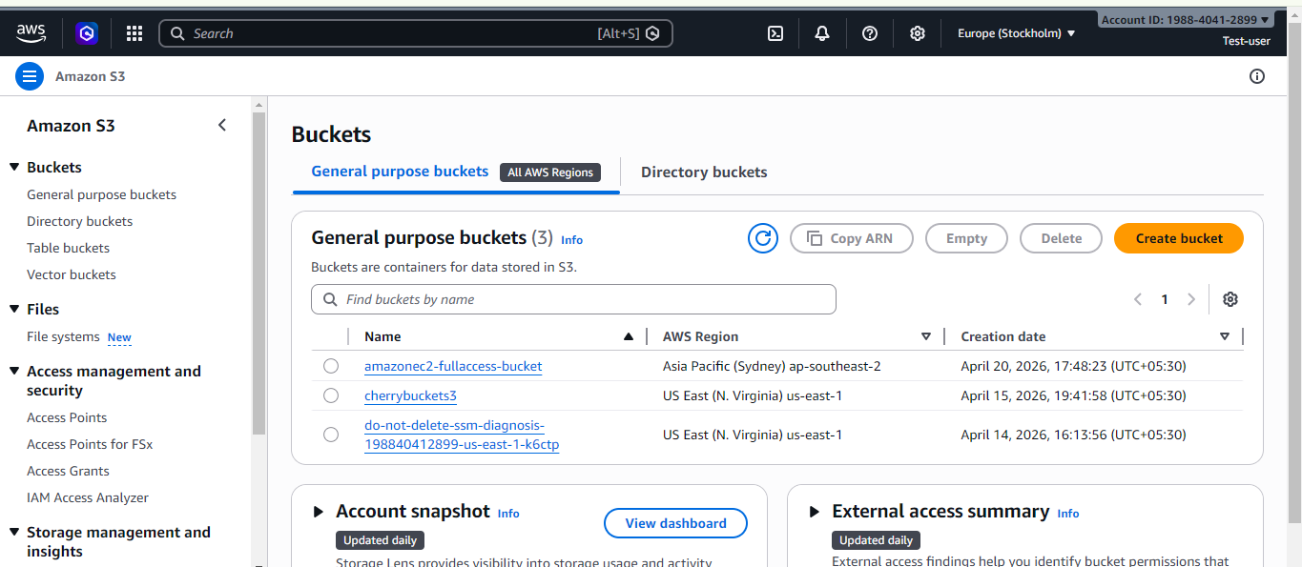
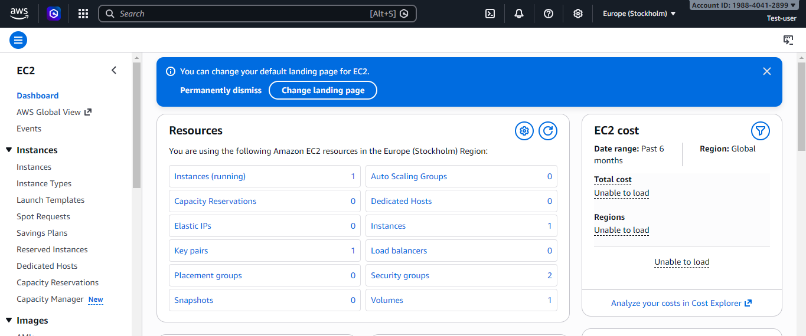
- Create one group in IAM and assign read access for EC2.
- Create IAM Group
  - In IAM Dashboard → Click User Groups
  - Click Create group
  - Enter group name
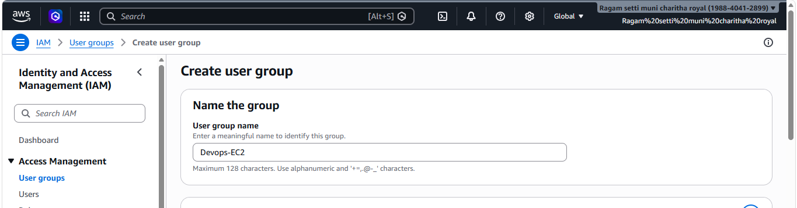
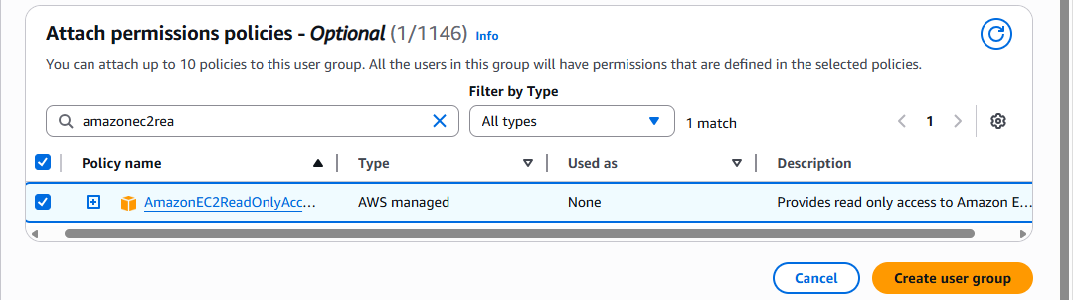
- Went to Attach permissions policies
- Searched and selected AmazonEC2ReadOnlyAccess
- This policy allows:
- View EC2 instances
- Check instance status
- View configurations and resources
- Cannot create, modify, or delete resources
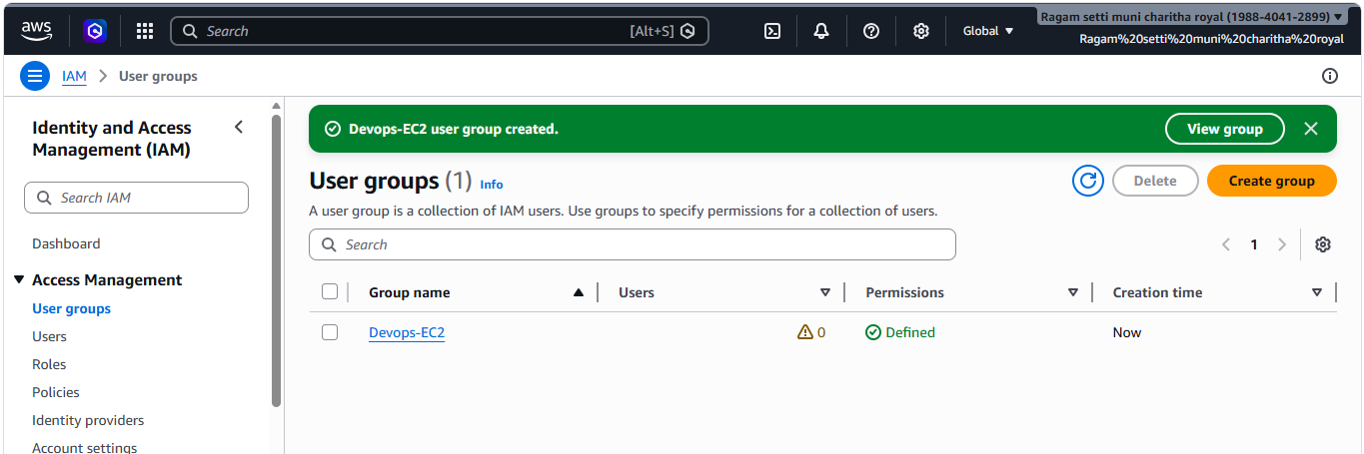
- Create a new user named "Devops" and add to the group created in task 2.
- Navigated to IAM Dashboard and opened Users.
- Clicked Create User and entered username as Devops.
- Enabled AWS Management Console access for login.
- Clicked Next.
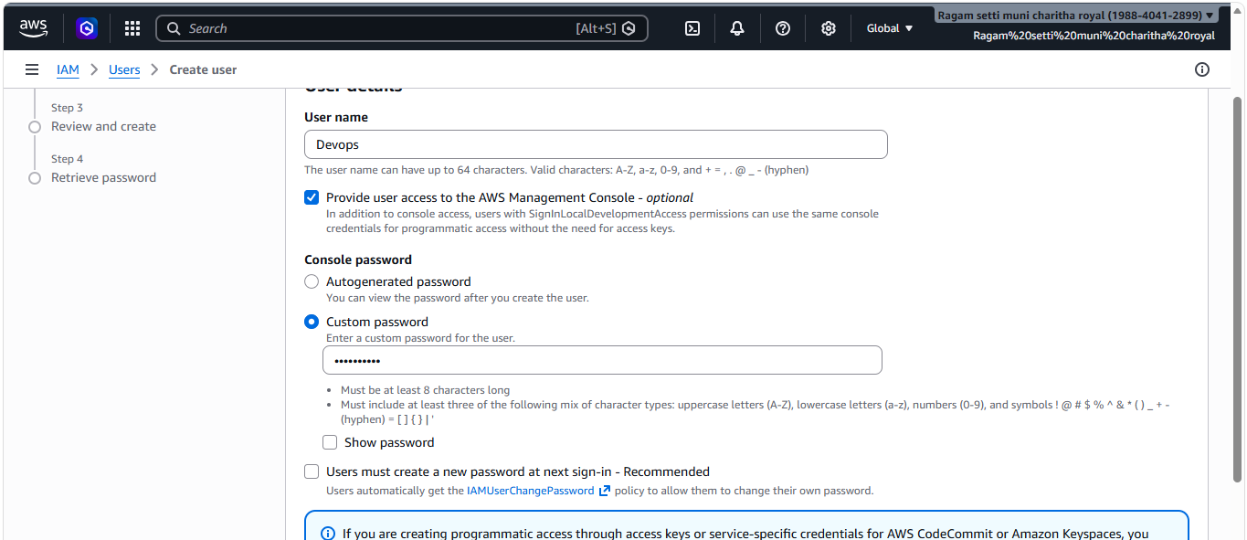
- Here I am adding user to the existing group
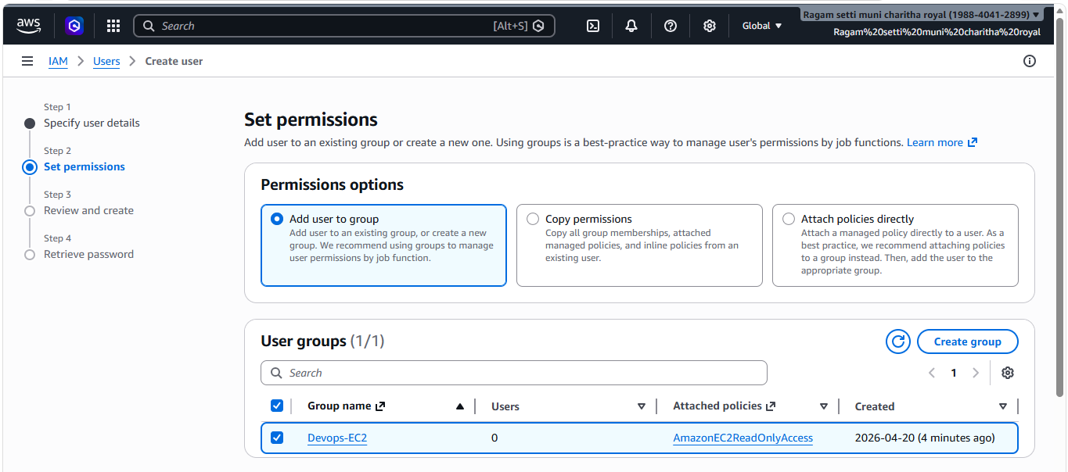
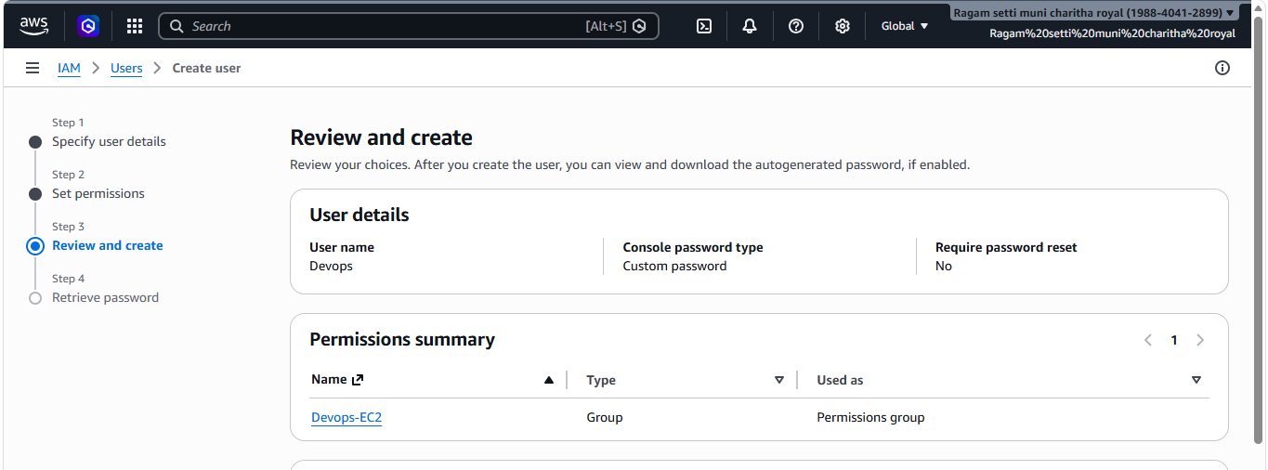
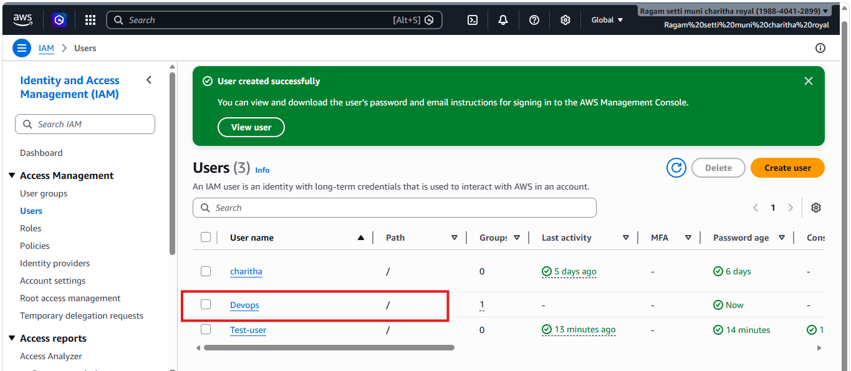
- Write a bash script to create an IAM user with VPC full access.
- I have created a file and wrote a bash script to create an IAM user with VPC full access
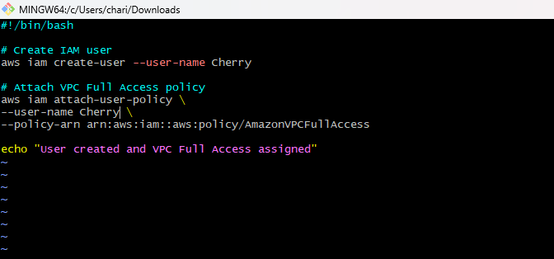
- Allowed permissions to execute
- Chmod +x
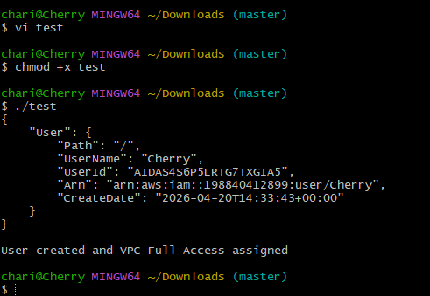

- Checked whether the user is created or not
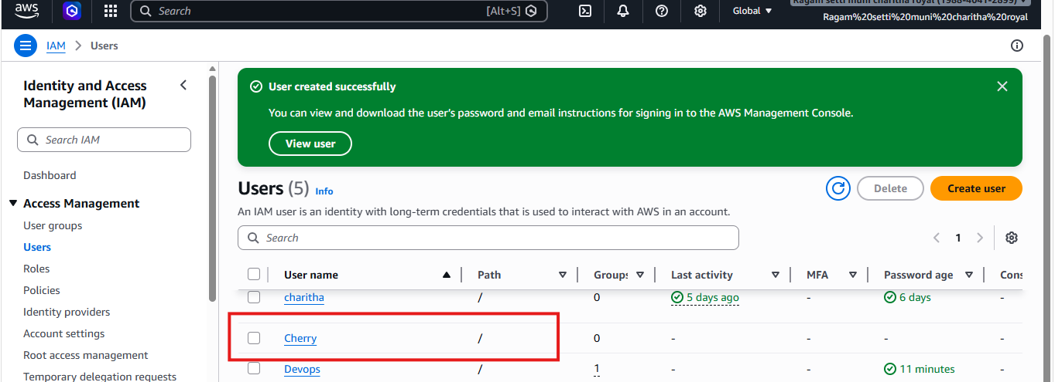
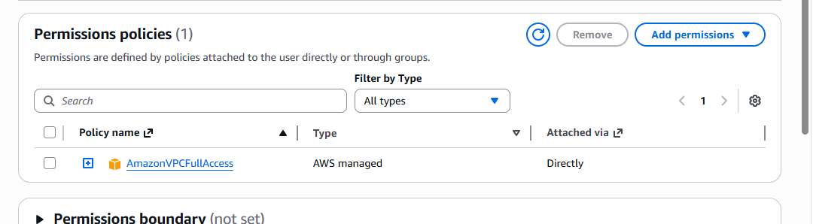
- Create an IAM policy to allow EC2 access for a specific user in specific regions only.
- First I have created policy
- I have added json policy
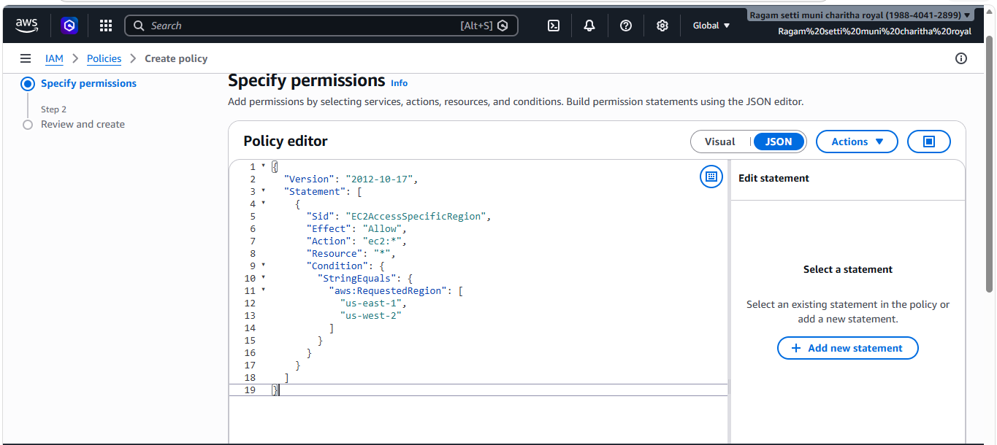
- Here I have added a policy name
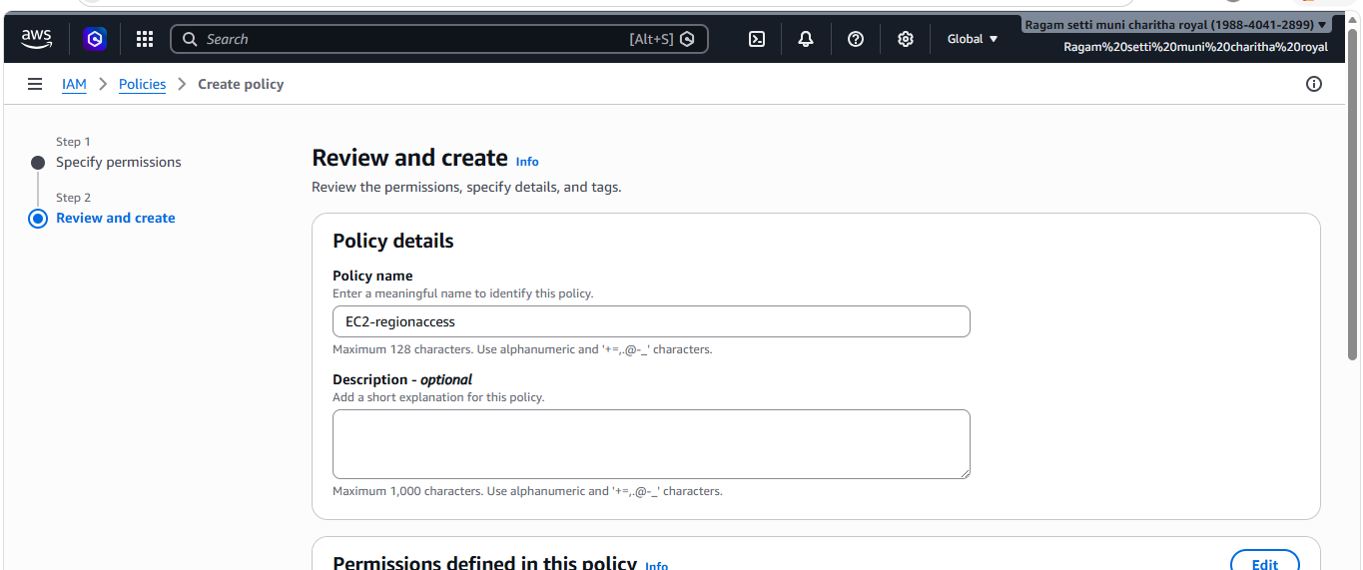
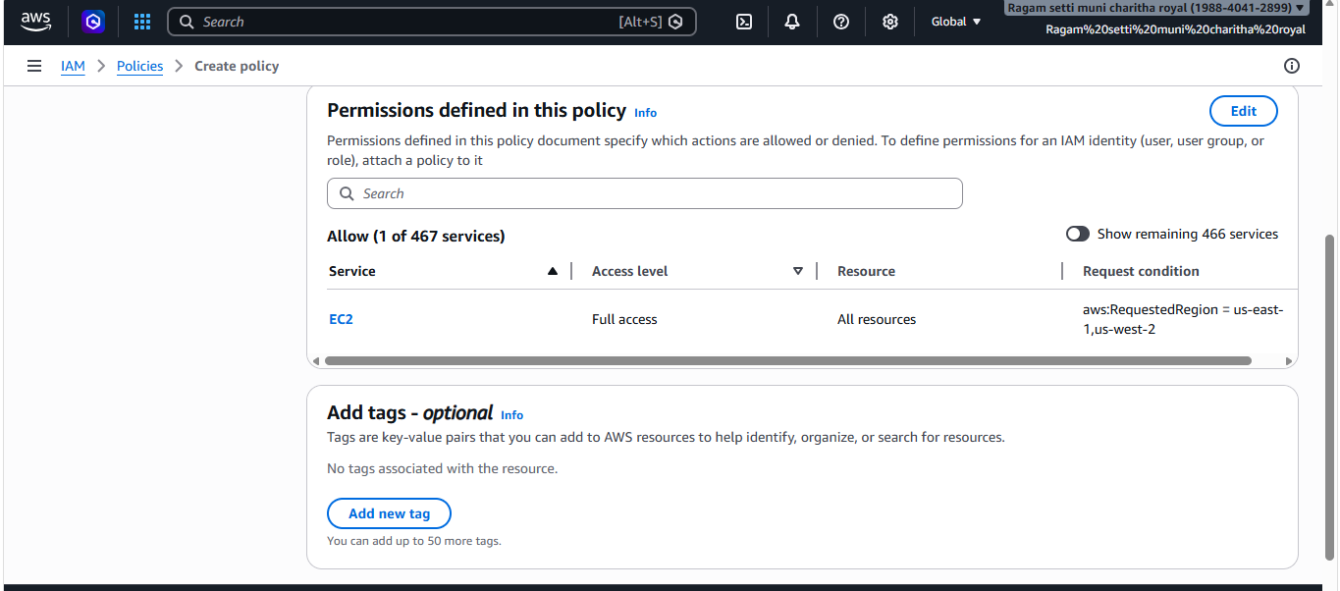
- verified policy
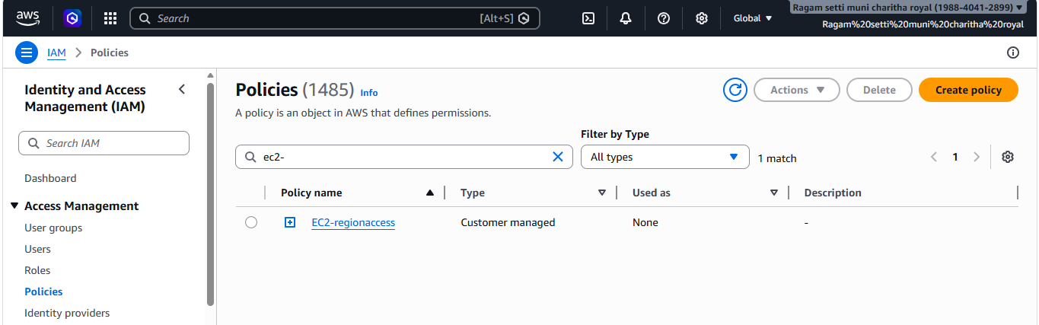
- Added policy to the user I have created
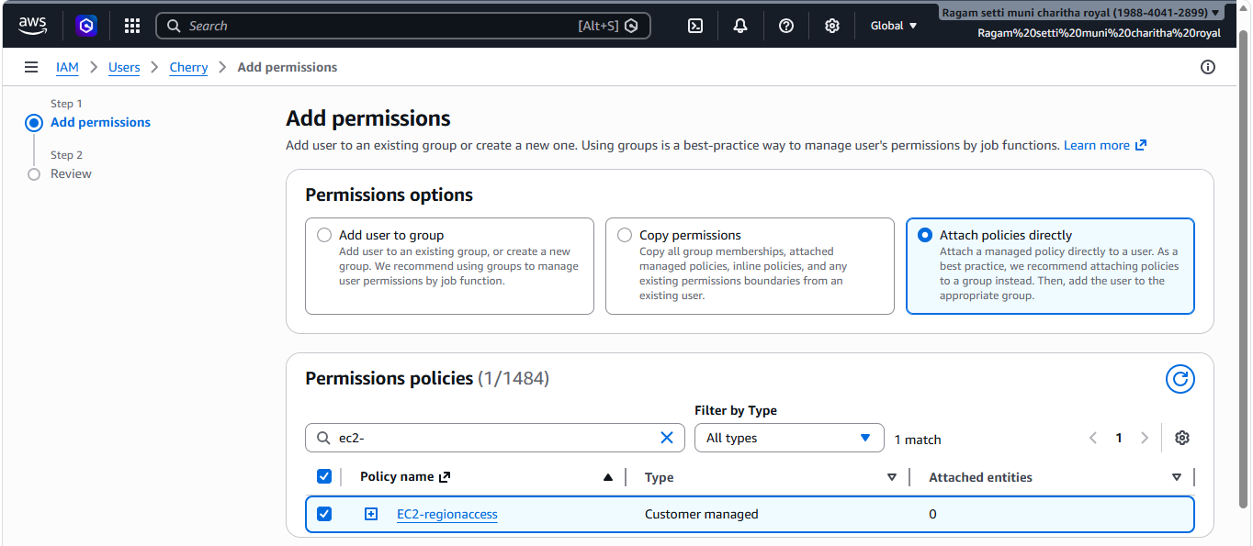
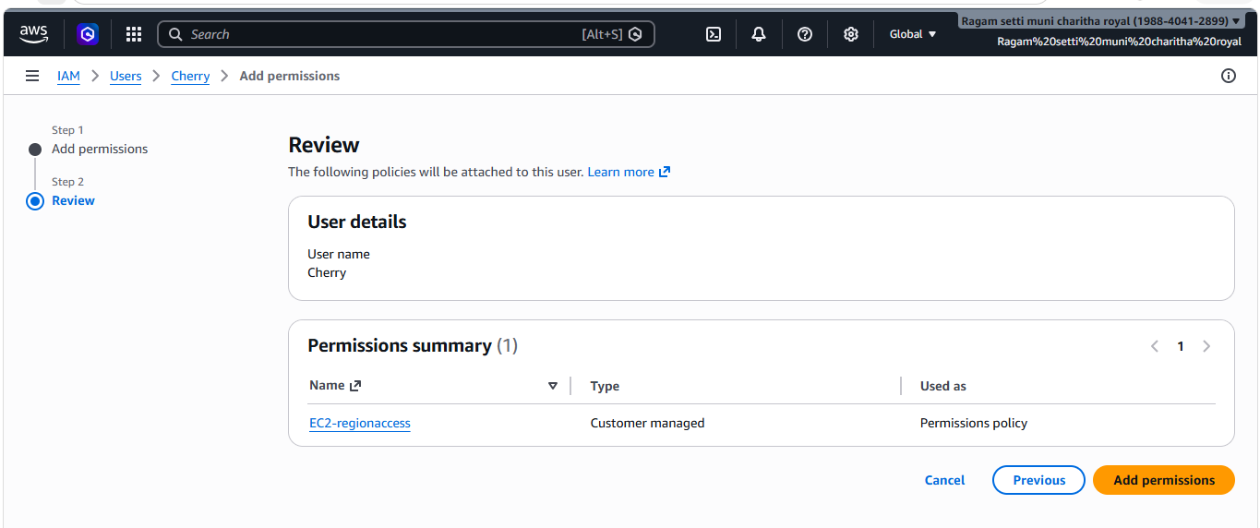
- Checked the policies to verify
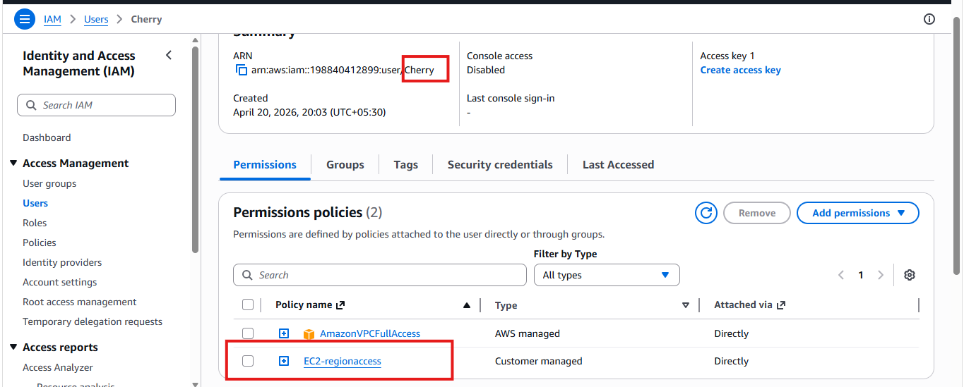

6. We have two accounts: Account A and Account B. Account A user should access an S3 bucket in Account
B.(Collaborate with a team member and execute this
- Created bucket
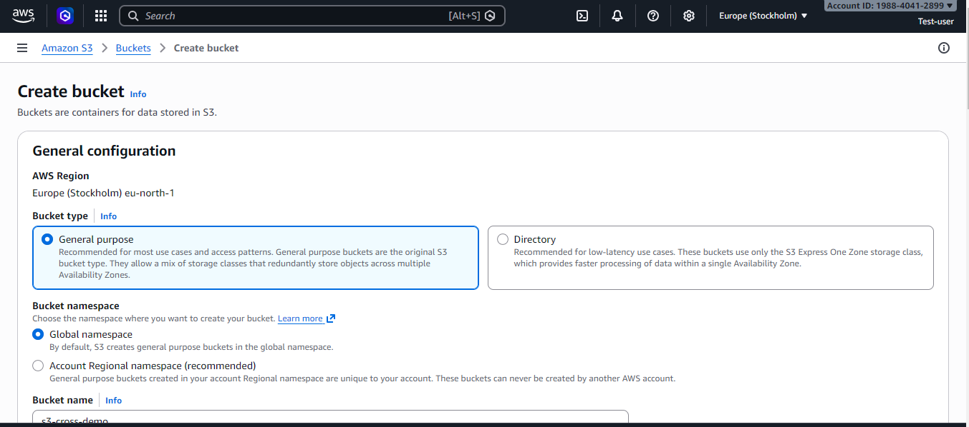
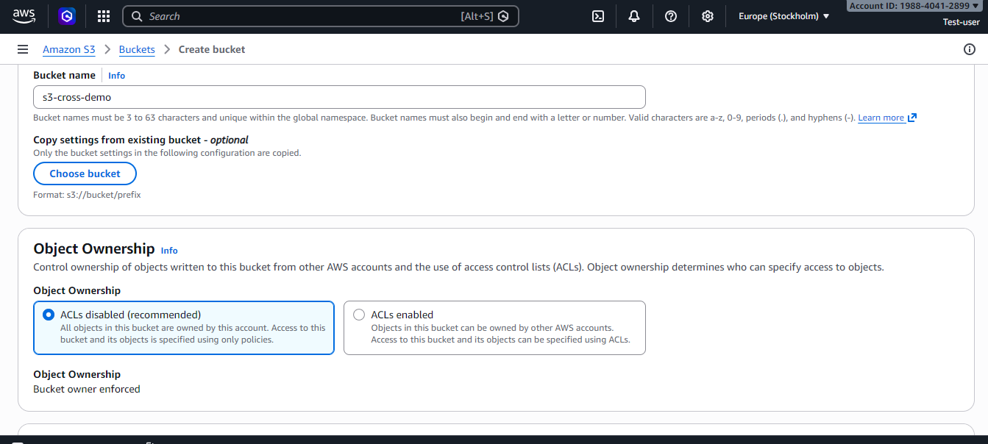
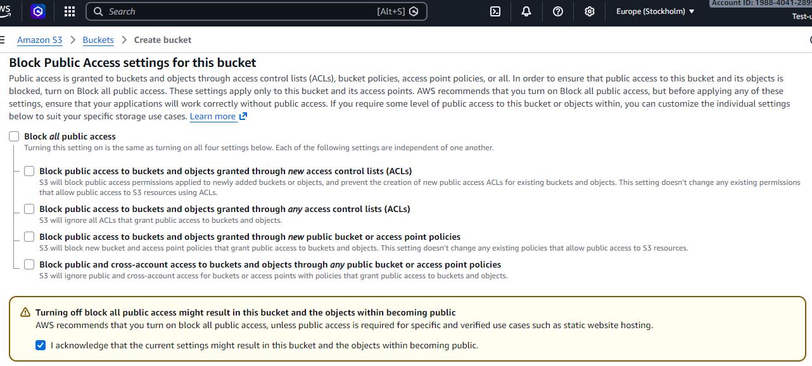
- Uploading file
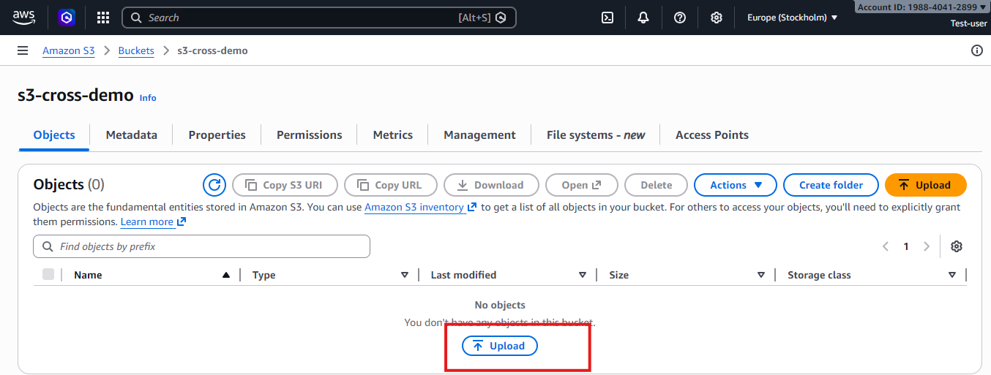
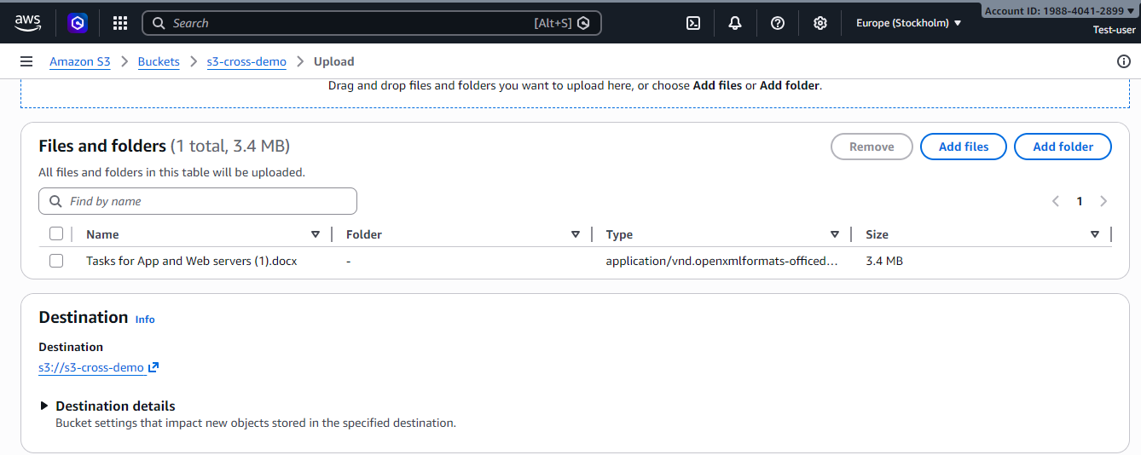
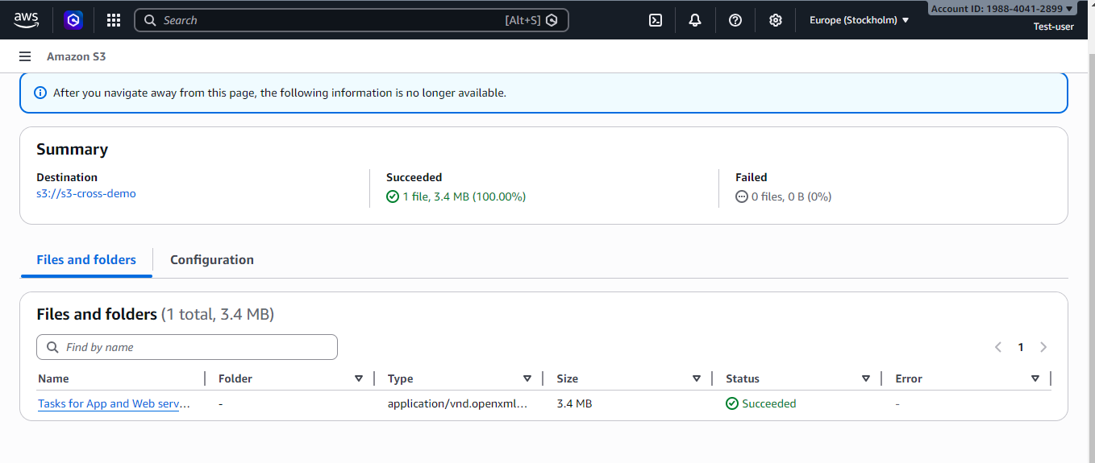
- Go to edit bucket policy to allow access to another account
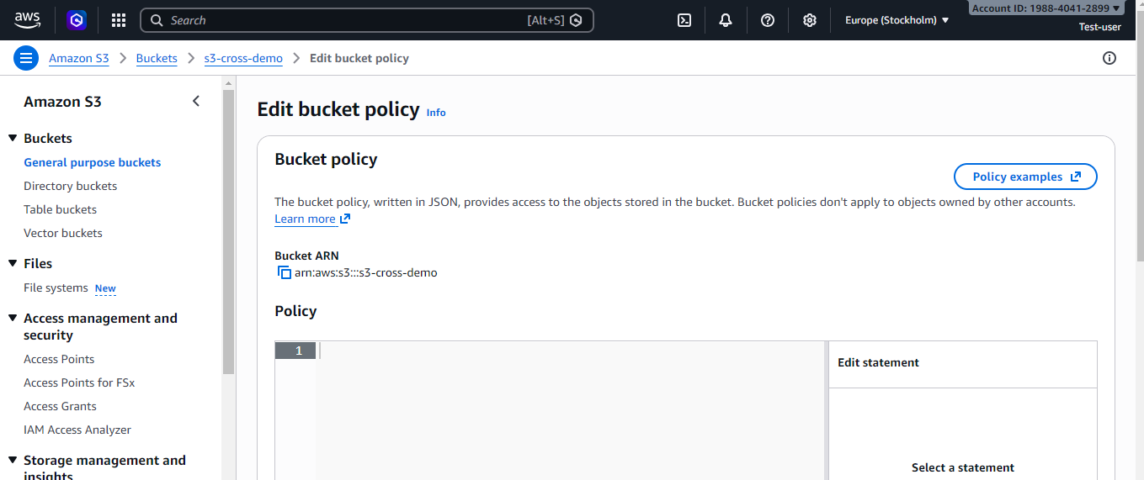

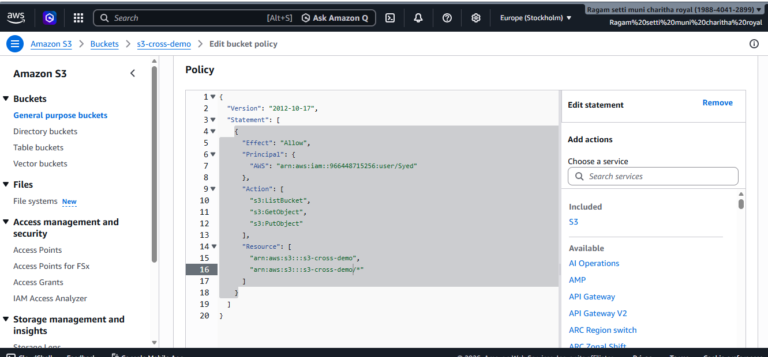
- Here I can access account B s3 bucket
